**Homework #06**

**x1(t) x1[n]**

**xp(t) xp[n]**

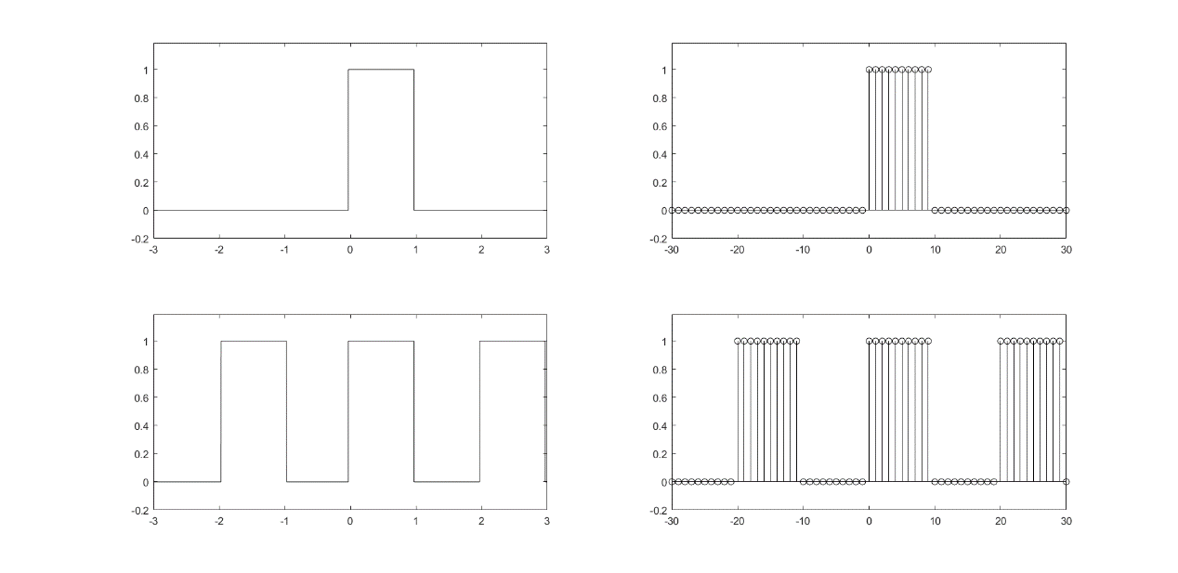

Please use MATLAB to plot the following transforms.

X1(f) **( CTFT of x1(t) )** X~1(f~) **( DTFT of x1[n] )**

Xp[k] **( CTFS of xp(t) )** X~p[k~] **( DTFS of xp[n] )**

